**Windows forms Handson Solutions**

**Date:**20-06-2021

**Name:**Asritha Cherukuri

**EmpId:** 916179

**HandsonForm1**

*Implementation:*

*Form1.cs*

using System;

using System.Collections.Generic;

using System.ComponentModel;

using System.Data;

using System.Drawing;

using System.Linq;

using System.Text;

using System.Threading.Tasks;

using System.Windows.Forms;

using System.Text.RegularExpressions;

namespace WinFormsApp2

{

public partial class Form1 : Form

{

public Form1()

{

InitializeComponent();

}

private void button1_Click_1(object sender, EventArgs e)

{

string number1 = tb1.Text;

string number2 = tb2.Text;

if (!Regex.IsMatch(number1, @"\d+$") || !Regex.IsMatch(number2, @"\d+$"))

{

MessageBox.Show(" Please enter valid input for the operands");

}

if (rd1.Checked)

{

MessageBox.Show((int.Parse(number1) + int.Parse(number2)).ToString());

}

else if (rd2.Checked)

{

MessageBox.Show((int.Parse(number1) - int.Parse(number2)).ToString());

}

else if (rd3.Checked)

{

MessageBox.Show((int.Parse(number1) * int.Parse(number2)).ToString());

}

else if (rd4.Checked)

{

MessageBox.Show((int.Parse(number1) / int.Parse(number2)).ToString());

}

else

{

MessageBox.Show("operation is not yet selected");

}

}

}

}

*Program.cs:*

using System;

using System.Collections.Generic;

using System.Linq;

using System.Threading.Tasks;

using System.Windows.Forms;

namespace WinFormsApp2

{

static class Program

{

/// <summary>

/// The main entry point for the application.

/// </summary>

[STAThread]

static void Main()

{

Application.SetHighDpiMode(HighDpiMode.SystemAware);

Application.EnableVisualStyles();

Application.SetCompatibleTextRenderingDefault(false);

Application.Run(new Form1());

}

}

}

*Form.designer.cs:*

namespace WinFormsApp2

{

partial class Form1

{

/// <summary>

/// Required designer variable.

/// </summary>

private System.ComponentModel.IContainer components = null;

/// <summary>

/// Clean up any resources being used.

/// </summary>

/// <param name="disposing">true if managed resources should be disposed; otherwise, false.</param>

protected override void Dispose(bool disposing)

{

if (disposing && (components != null))

{

components.Dispose();

}

base.Dispose(disposing);

}

#region Windows Form Designer generated code

/// <summary>

/// Required method for Designer support - do not modify

/// the contents of this method with the code editor.

/// </summary>

private void InitializeComponent()

{

this.tb1 = new System.Windows.Forms.TextBox();

this.tb2 = new System.Windows.Forms.TextBox();

this.rd1 = new System.Windows.Forms.RadioButton();

this.rd2 = new System.Windows.Forms.RadioButton();

this.rd3 = new System.Windows.Forms.RadioButton();

this.rd4 = new System.Windows.Forms.RadioButton();

this.b1 = new System.Windows.Forms.Button();

this.SuspendLayout();

//

// tb1

//

this.tb1.Location = new System.Drawing.Point(212, 77);

this.tb1.Name = "tb1";

this.tb1.Size = new System.Drawing.Size(100, 23);

this.tb1.TabIndex = 0;

this.tb1.TextChanged += new System.EventHandler(this.tb1_TextChanged);

//

// tb2

//

this.tb2.Location = new System.Drawing.Point(212, 179);

this.tb2.Name = "tb2";

this.tb2.Size = new System.Drawing.Size(100, 23);

this.tb2.TabIndex = 1;

this.tb2.TextChanged += new System.EventHandler(this.tb2_TextChanged);

//

// rd1

//

this.rd1.AutoSize = true;

this.rd1.Location = new System.Drawing.Point(454, 66);

this.rd1.Name = "rd1";

this.rd1.Size = new System.Drawing.Size(71, 19);

this.rd1.TabIndex = 2;

this.rd1.Text = "Addition";

this.rd1.UseVisualStyleBackColor = true;

this.rd1.CheckedChanged += new System.EventHandler(this.radioButton1_CheckedChanged);

//

// rd2

//

this.rd2.AutoSize = true;

this.rd2.Location = new System.Drawing.Point(454, 124);

this.rd2.Name = "rd2";

this.rd2.Size = new System.Drawing.Size(86, 19);

this.rd2.TabIndex = 3;

this.rd2.Text = "Subtraction";

this.rd2.UseVisualStyleBackColor = true;

this.rd2.CheckedChanged += new System.EventHandler(this.radioButton2_CheckedChanged);

//

// rd3

//

this.rd3.AutoSize = true;

this.rd3.Location = new System.Drawing.Point(616, 66);

this.rd3.Name = "rd3";

this.rd3.Size = new System.Drawing.Size(99, 19);

this.rd3.TabIndex = 4;

this.rd3.Text = "Multiplication";

this.rd3.UseVisualStyleBackColor = true;

this.rd3.CheckedChanged += new System.EventHandler(this.rd3_CheckedChanged);

//

// rd4

//

this.rd4.AutoSize = true;

this.rd4.Location = new System.Drawing.Point(616, 124);

this.rd4.Name = "rd4";

this.rd4.Size = new System.Drawing.Size(67, 19);

this.rd4.TabIndex = 5;

this.rd4.Text = "Division";

this.rd4.UseVisualStyleBackColor = true;

this.rd4.CheckedChanged += new System.EventHandler(this.radioButton4_CheckedChanged);

//

// b1

//

this.b1.Location = new System.Drawing.Point(564, 179);

this.b1.Name = "b1";

this.b1.Size = new System.Drawing.Size(75, 23);

this.b1.TabIndex = 6;

this.b1.Text = "Answer";

this.b1.UseVisualStyleBackColor = true;

this.b1.Click += new System.EventHandler(this.button1_Click_1);

//

// Form1

//

this.AutoScaleDimensions = new System.Drawing.SizeF(7F, 15F);

this.AutoScaleMode = System.Windows.Forms.AutoScaleMode.Font;

this.ClientSize = new System.Drawing.Size(800, 450);

this.Controls.Add(this.b1);

this.Controls.Add(this.rd4);

this.Controls.Add(this.rd3);

this.Controls.Add(this.rd2);

this.Controls.Add(this.rd1);

this.Controls.Add(this.tb2);

this.Controls.Add(this.tb1);

this.Name = "Form1";

this.Text = "Form1";

this.ResumeLayout(false);

this.PerformLayout();

}

#endregion

private System.Windows.Forms.TextBox tb1;

private System.Windows.Forms.TextBox tb2;

private System.Windows.Forms.RadioButton rd1;

private System.Windows.Forms.RadioButton rd2;

private System.Windows.Forms.RadioButton rd3;

private System.Windows.Forms.RadioButton rd4;

private System.Windows.Forms.Button b1;

}

}

*Output:*

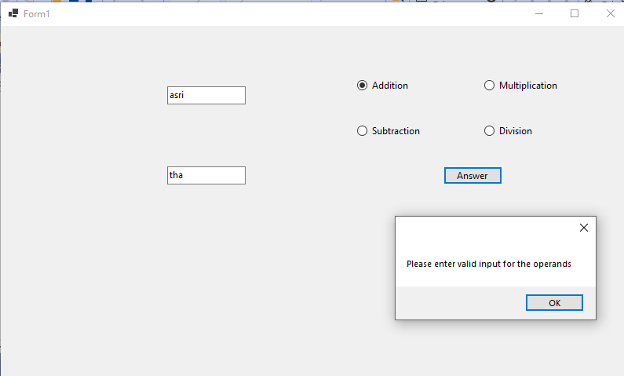

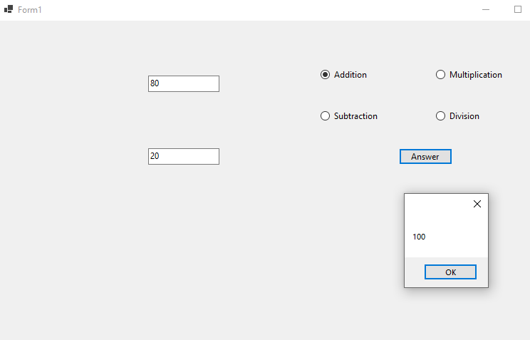

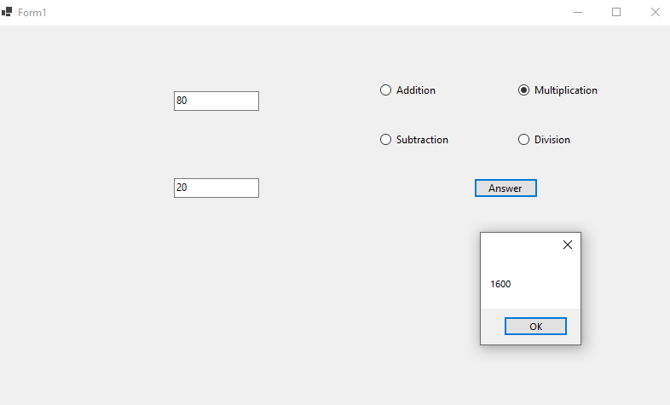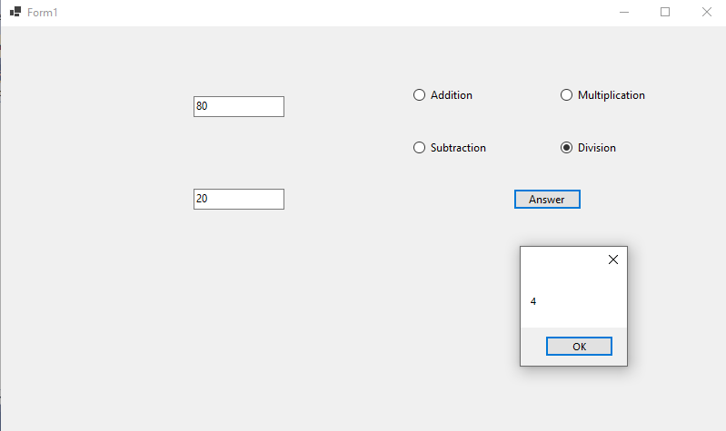

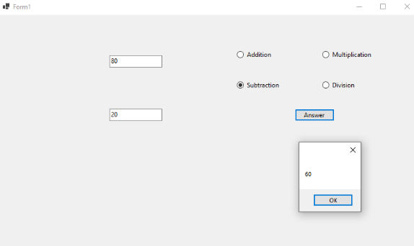

**HandsonForm2**

*Implementation:*

*Form.cs*

using System;

using System.Collections.Generic;

using System.ComponentModel;

using System.Data;

using System.Drawing;

using System.Linq;

using System.Text;

using System.Threading.Tasks;

using System.Windows.Forms;

namespace WinFormsApp3

{

public partial class Form1 : Form

{

public Form1()

{

InitializeComponent();

}

private void u1_Click(object sender, EventArgs e)

{

OpenFileDialog op = new OpenFileDialog

{

InitialDirectory = @"C:\",

Filter = "image(*.jpg) | *.jpg|| *.png"

};

if (op.ShowDialog() == DialogResult.OK)

{

pictureBox1.SizeMode = PictureBoxSizeMode.StretchImage;

pictureBox1.Image = new Bitmap(op.FileName);

}

}

}

}

*Program.cs:*

using System;

using System.Collections.Generic;

using System.Linq;

using System.Threading.Tasks;

using System.Windows.Forms;

namespace WinFormsApp3

{

static class Program

{

/// <summary>

/// The main entry point for the application.

/// </summary>

[STAThread]

static void Main()

{

Application.SetHighDpiMode(HighDpiMode.SystemAware);

Application.EnableVisualStyles();

Application.SetCompatibleTextRenderingDefault(false);

Application.Run(new Form1());

}

}

}

*Form.Designer.cs:*

namespace WinFormsApp3

{

partial class Form1

{

/// <summary>

/// Required designer variable.

/// </summary>

private System.ComponentModel.IContainer components = null;

/// <summary>

/// Clean up any resources being used.

/// </summary>

/// <param name="disposing">true if managed resources should be disposed; otherwise, false.</param>

protected override void Dispose(bool disposing)

{

if (disposing && (components != null))

{

components.Dispose();

}

base.Dispose(disposing);

}

#region Windows Form Designer generated code

/// <summary>

/// Required method for Designer support - do not modify

/// the contents of this method with the code editor.

/// </summary>

private void InitializeComponent()

{

this.pictureBox1 = new System.Windows.Forms.PictureBox();

this.u1 = new System.Windows.Forms.Button();

((System.ComponentModel.ISupportInitialize)(this.pictureBox1)).BeginInit();

this.SuspendLayout();

//

// pictureBox1

//

this.pictureBox1.Location = new System.Drawing.Point(390, 65);

this.pictureBox1.Name = "pictureBox1";

this.pictureBox1.Size = new System.Drawing.Size(326, 184);

this.pictureBox1.TabIndex = 0;

this.pictureBox1.TabStop = false;

//

// u1

//

this.u1.Location = new System.Drawing.Point(218, 112);

this.u1.Name = "u1";

this.u1.Size = new System.Drawing.Size(75, 23);

this.u1.TabIndex = 1;

this.u1.Text = "Upload";

this.u1.UseVisualStyleBackColor = true;

this.u1.Click += new System.EventHandler(this.u1_Click);

//

// Form1

//

this.AutoScaleDimensions = new System.Drawing.SizeF(7F, 15F);

this.AutoScaleMode = System.Windows.Forms.AutoScaleMode.Font;

this.ClientSize = new System.Drawing.Size(800, 450);

this.Controls.Add(this.u1);

this.Controls.Add(this.pictureBox1);

this.Name = "Form1";

this.Text = "Form1";

((System.ComponentModel.ISupportInitialize)(this.pictureBox1)).EndInit();

this.ResumeLayout(false);

}

#endregion

private System.Windows.Forms.PictureBox pictureBox1;

private System.Windows.Forms.Button u1;

}

*Output:*

